Destination of the Month: Aruba and the ABC Islands
Sunshine you can count on, three islands to explore
Cruise and Adventure Travel | November 2026
Winter is coming to much of the country, so this month we're heading south to the Dutch Caribbean: Aruba, Bonaire and Curaçao, called the ABC Islands. They lie off the coast of Venezuela, below the main Atlantic hurricane belt (Aruba.com). That means dry, breezy, sunny weather nearly all year. Each island has its own character. Aruba has the famous beaches, Bonaire is for divers and nature lovers, and Curaçao has color, culture and history. Fly in for a week of island time, or cruise and see all three in one trip.

Meet the Islands
Aruba: One Happy Island. Long white-sand beaches like Eagle Beach and Palm Beach, calm turquoise water, the windswept divi-divi trees, and a lively capital in Oranjestad. Aruba is the easiest of the three to reach and works well for couples, families and first-time Caribbean travelers.
Bonaire: Diver's Paradise. Quiet, unhurried and full of nature. The waters around the island are a protected national marine park, and you can wade in for world-class snorkeling and shore diving. Pink flamingos feed in the salt pans in the south.
Curaçao: Color and Culture. The pastel waterfront of Willemstad is a UNESCO World Heritage Site (Bonaire.com). Curaçao is the largest of the three (Bonaire.com), with hidden coves, great food and a colorful mix of Caribbean, Dutch and Latin influences.

Getting There by Air
Aruba has some of the best air service in the Caribbean. Its Queen Beatrix International Airport (AUA) has nonstop flights from about 16 U.S. airports. Flights take roughly 3 hours from Miami and 4 to 4.5 hours from the East Coast (Aruba Playbook).
- Nonstop airlines: American (Charlotte, Miami, Philadelphia, Chicago, Dallas-Fort Worth), JetBlue (Boston, Fort Lauderdale, New York JFK), Delta (Atlanta, JFK, plus seasonal Boston and Minneapolis), United (Houston, Newark, Washington Dulles) and Southwest (Baltimore and Boston) (Aruba Playbook). Southwest also flies nonstop from Orlando and Atlanta (Caribbean Journal).
- From the Carolinas: American's Charlotte nonstop is the easiest connection for travelers from Myrtle Beach and the Grand Strand (Aruba Playbook).
- New routes: Air Transat starts a weekly nonstop from Montreal on December 12, 2026. Southwest adds a seasonal Saturday nonstop from Nashville on March 13, 2027 (Aruba Playbook).
- An easy trip home: Aruba has U.S. Customs and Border Protection preclearance (CBP). You clear U.S. customs before you board and land back home as a domestic arrival. Arrive at the airport early to allow for it.
- Island hopping: Bonaire and Curaçao are short regional flights from Aruba. From Curaçao, Bonaire is about 30 minutes by plane and Aruba about 25 minutes (Traveler Center).

Getting There by Cruise
Southern Caribbean cruises call at the ABC Islands all year. The most popular months are December through April (Cruise Critic). Celebrity, Princess, Carnival, Disney, Royal Caribbean and Norwegian all sail here (Cruise Critic).
Sample sailings this season:
- Celebrity Cruises: Aruba, Curaçao and Bonaire round trip from Fort Lauderdale, with departures December 5, 2026, and January 2, 2027 (Cruise Critic).
- Royal Caribbean: Adventure of the Seas, 8 nights from Fort Lauderdale to Nassau, Aruba and Curaçao, departing December 5, 2026 (KAYAK). Freedom of the Seas offers 9-night Southern Caribbean sailings from Miami (KAYAK).
- Carnival: Carnival Magic, 8 nights from Miami to Aruba and Curaçao, departing January 9, 2027 (KAYAK).
- MSC Cruises: MSC Poesia returns to Miami for winter 2026/27 with 10-night sailings to Aruba, Bonaire and Curaçao (MSC Cruises).
- Luxury option: Silversea's 14-day Southern Caribbean holiday voyage from Miami, December 22, 2026, to January 5, 2027, includes all three ABC Islands (Silversea).
Coming soon: Margaritaville at Sea's Beachcomber starts sailing from Miami in January 2027 with 7-night itineraries that include Aruba, Bonaire and Curaçao. Disney's 2027–28 season adds Southern Caribbean sailings from San Juan (Miami Herald).
Cruise ports: Oranjestad (Aruba), Kralendijk (Bonaire) and Willemstad (Curaçao) are all walkable from the pier. In Aruba, the shopping street is about a ten-minute walk from the ship (Aruba Tourism).
Cruise or stay? A cruise is the easiest way to sample all three islands in one trip. A resort stay gives you more time on the beach or underwater. Many of our clients combine the two: a cruise first, then a few extra nights in Aruba.

Best Time to Go
The ABC Islands work almost any month, which is rare in the Caribbean. Peak season, with the highest prices, runs December through April (Where Best). November and early December are a sweet spot, with great weather before peak holiday pricing. Since the islands are south of the main hurricane belt, a fall trip carries less weather risk than most of the Caribbean. The risk is low, though, not zero.

Top Experiences
Aruba
- Spend a day on Eagle Beach, often ranked among the best beaches in the world, and find the famous divi-divi trees
- Explore the rugged north coast and Arikok National Park by jeep or UTV
- Snorkel the shipwrecks and reefs off Malmok and Boca Catalina
- Take a sunset catamaran sail along Palm Beach
- Ride the free trolley through colorful downtown Oranjestad (Aruba Tourism)
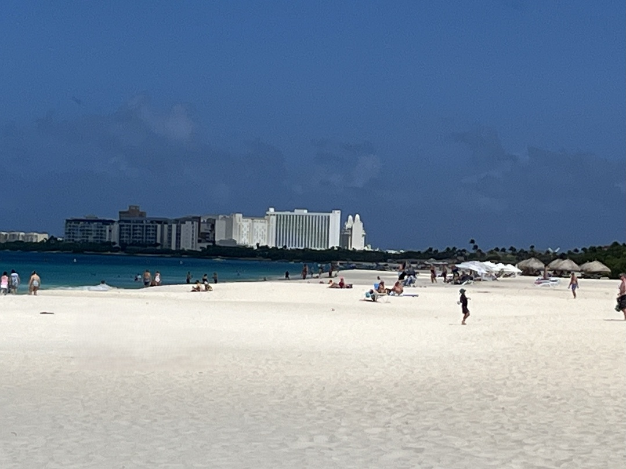
Bonaire
- Shore dive or snorkel the Bonaire National Marine Park
- See flamingos at the southern salt flats
- Kayak the mangroves at Lac Bay
- Explore Washington Slagbaai National Park
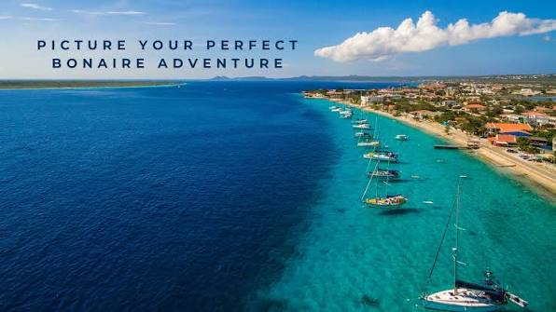

Curaçao
- Walk the colorful Handelskade and cross the Queen Emma floating bridge in Willemstad
- Swim at hidden west-end coves like Grote Knip and Playa Lagun
- Taste the local food at the Old Market (Plasa Bieuw) and try Blue Curaçao liqueur where it's made
- Snorkel with sea turtles at Playa Piskado
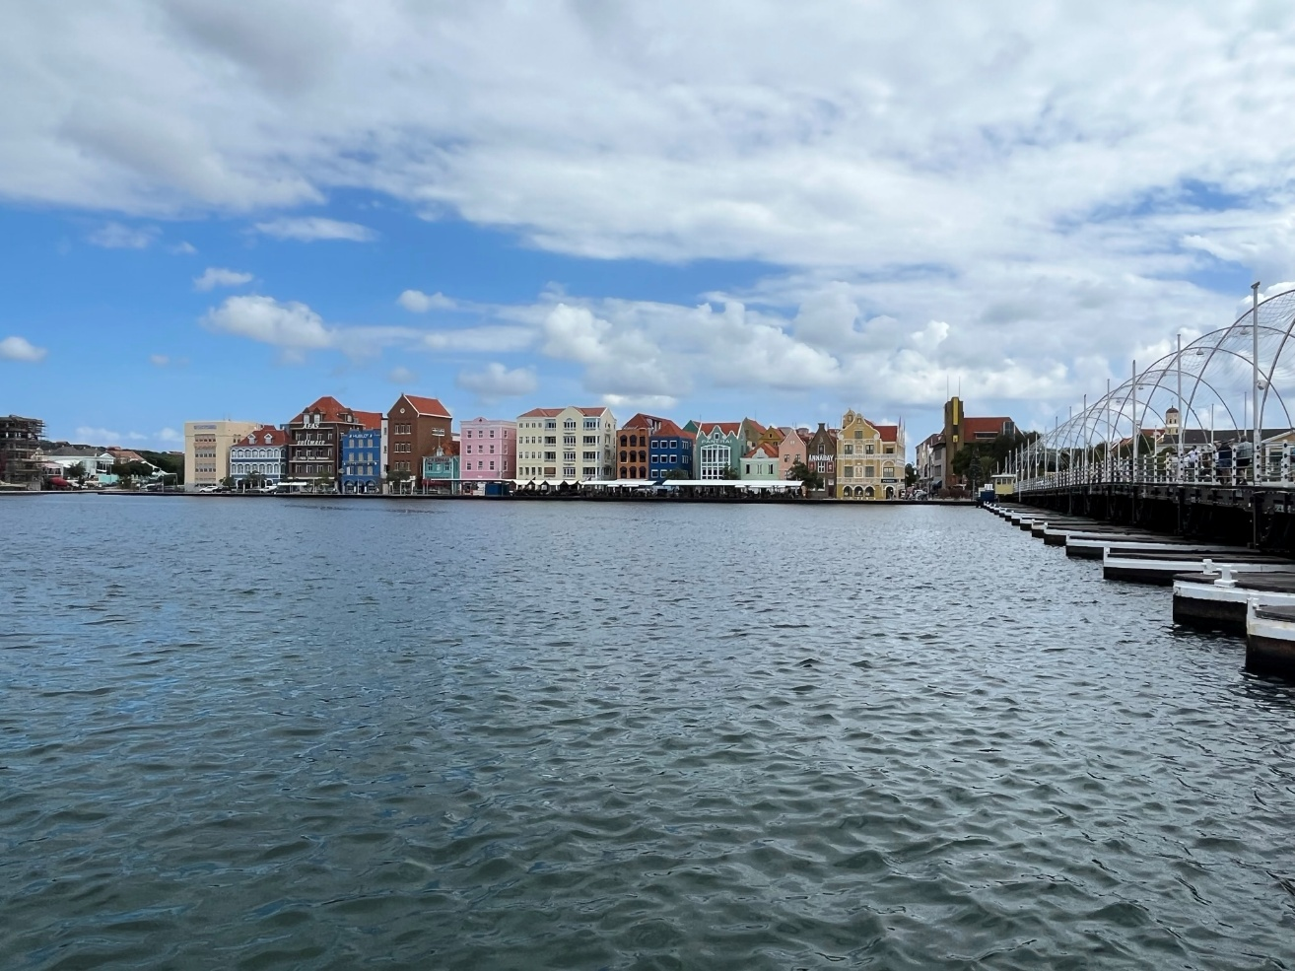

Practical Tips
Documents and entry fees
- Aruba: U.S. citizens need a valid passport, and no visa is required for stays of 30 days or less (U.S. State Department). Every traveler, infants included, must complete the online ED Card within 7 days before travel (Aruba.com). Air arrivals also pay a $20 sustainability fee through the same form (Aruba.com). Use only the official site, edcardaruba.aw. Lookalike sites charge extra for the same form (One Happy Aruba).
- Bonaire: A $75 visitor entry tax applies to visitors 13 and older (children 12 and under pay $10), and cruise passengers pay $10, which the cruise line handles (Government of Bonaire). Pay online up to 7 days ahead at tourismtax.bonairegov.com (Government of Bonaire). Swimmers, snorkelers and divers also pay a $40 STINAPA nature fee that covers the calendar year (Bonaire.com).
- Curaçao: Fill out the free Digital Immigration (DI) Card at dicardcuracao.com up to 7 days before departure (Traveler Center).
Money
- Aruba uses the Aruban florin, Curaçao uses the Caribbean guilder (introduced in 2025), and Bonaire uses the U.S. dollar (Bonaire.com). U.S. dollars and credit cards are widely accepted across all three islands (Traveler Center).
Packing
- Reef-safe sunscreen, a hat and sunglasses. The sun is strong and the trade winds can hide how hot it is.
- Water shoes for rocky coves and shore entries
- Your own snorkel mask if you have one you like
- A light layer for evening breezes and air-conditioned ships
- A copy of your passport, plus your ED Card or DI Card and fee confirmations saved on your phone
Entry rules and fees can change, so check them again shortly before you travel.

Let's Plan Your ABC Islands Escape
Whether you'd like a week on Eagle Beach, a dive trip to Bonaire, or a cruise that visits all three islands, Cruise and Adventure Travel will help you compare ships, cabins, resorts and flights, and take care of the details.
Contact Mike Langlais today
Phone: 401-500-5839
Email: travelbymikel@gmail.com
Web: www.cruiseandadventuretravel.com

